Assignment 2

Q1. In your Github account, create a new repository ‘linux_assignments’. Put all the docx/pdf file solutions for your linux assignments in that folder

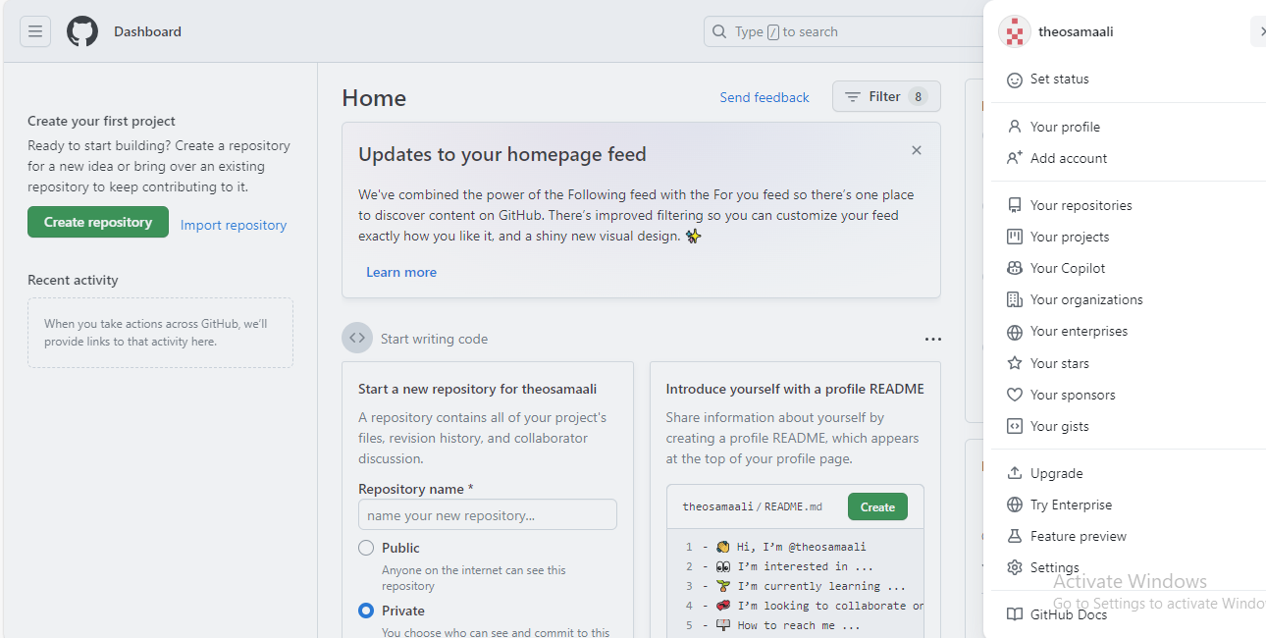

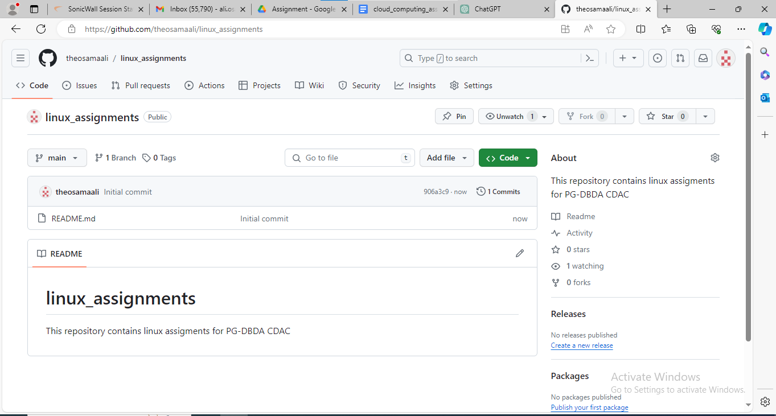

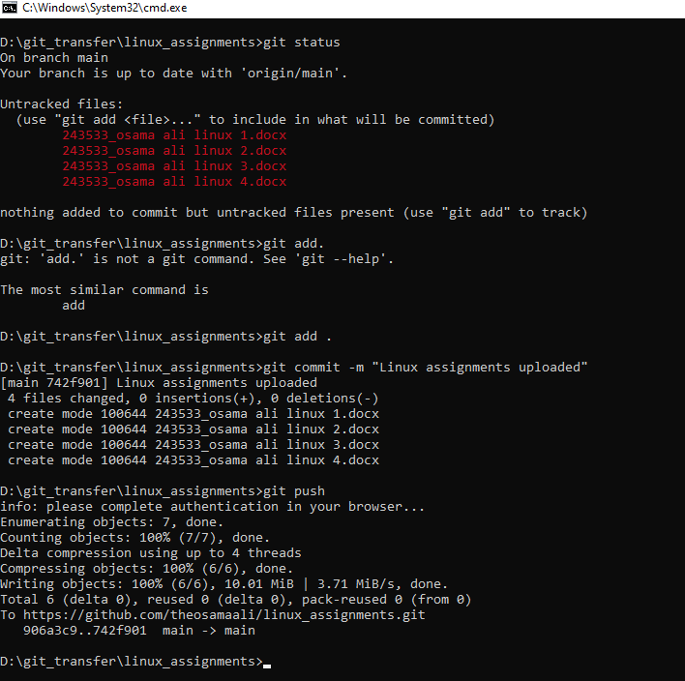

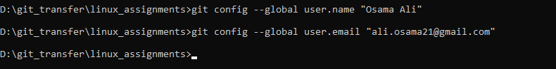

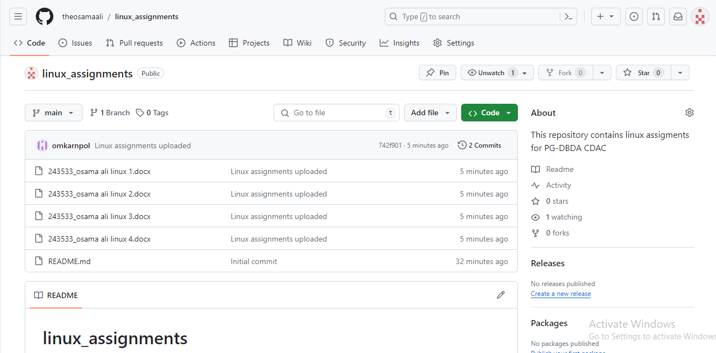

Q2. In your Github account, create a new repository ‘linux_scripts’. Put at least 5 .sh files in that folder.

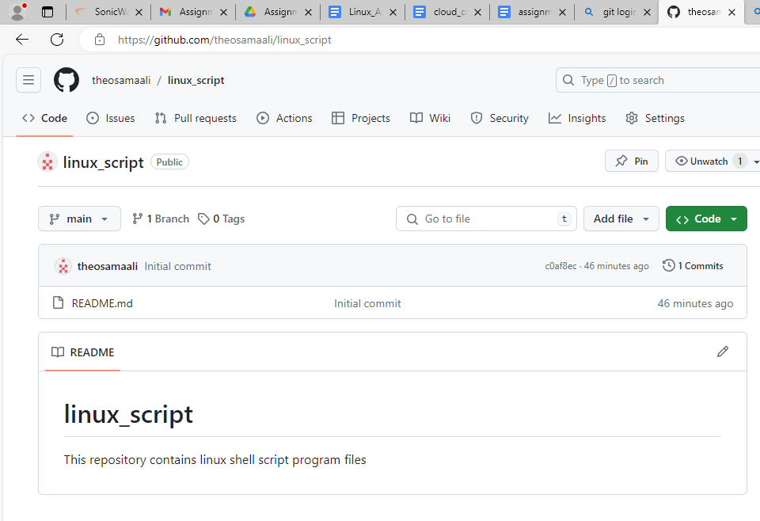

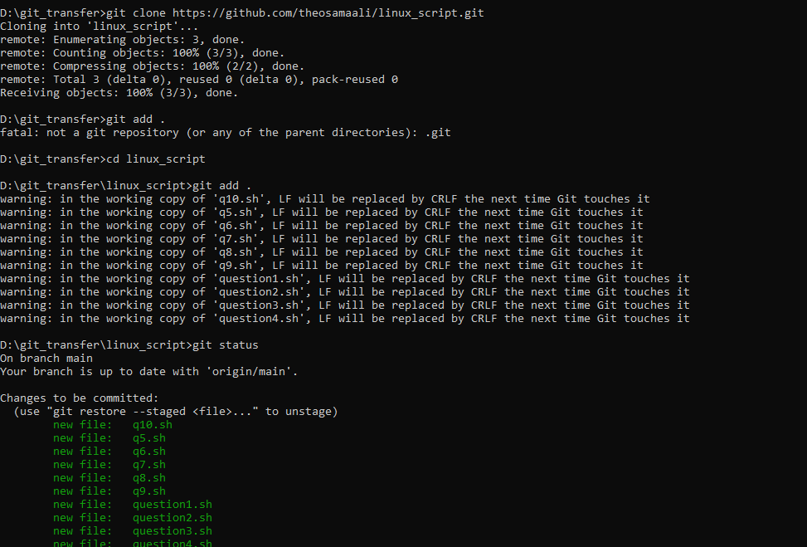

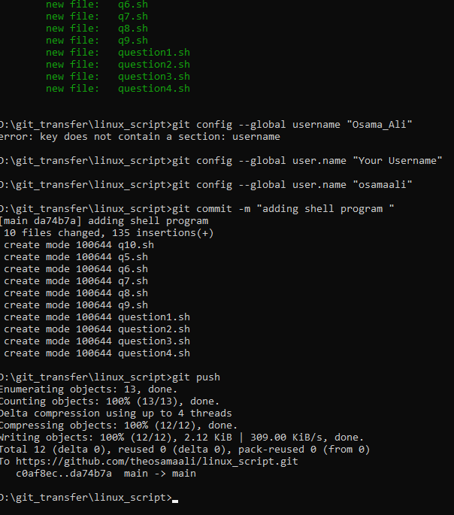

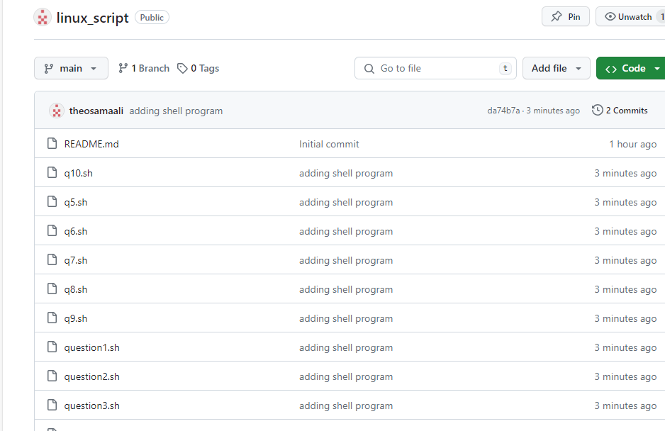

Q3. Login to AWS console. Create a new instance of EC2 with Ubuntu. On this instance install git

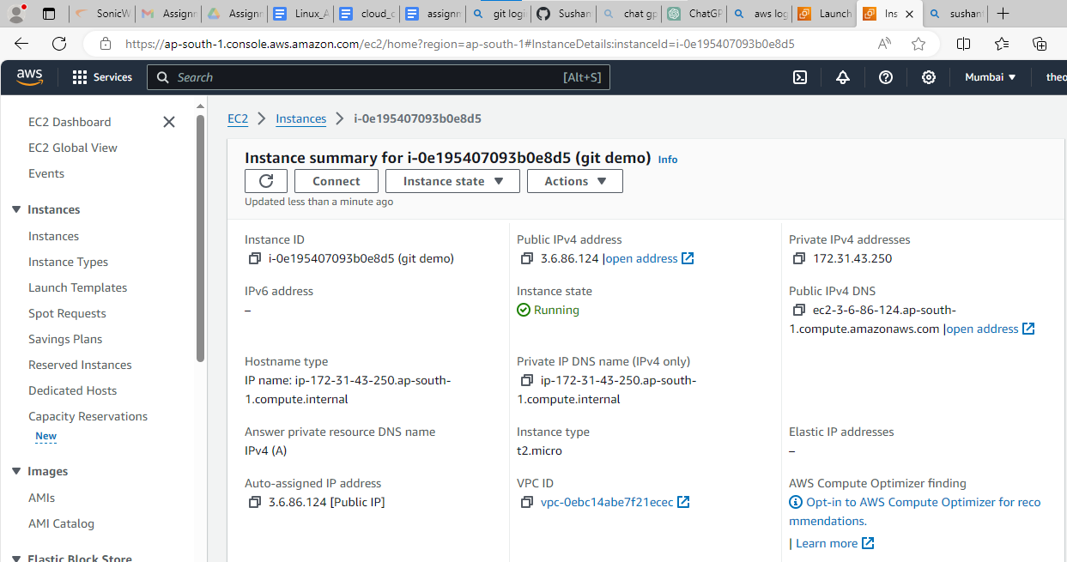

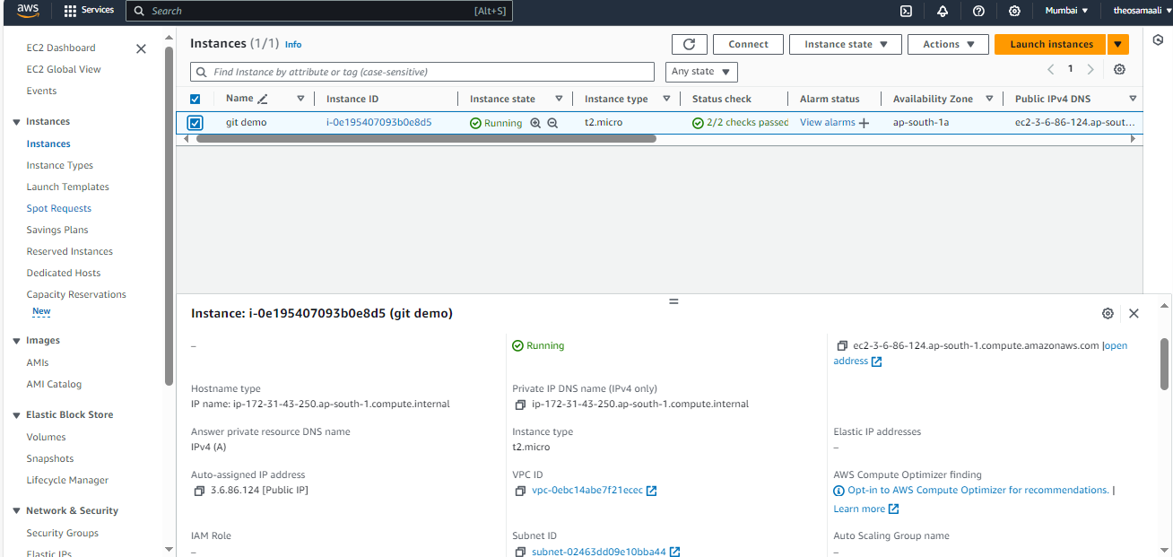

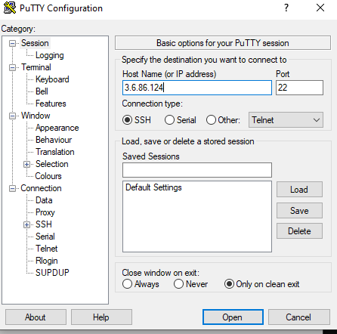

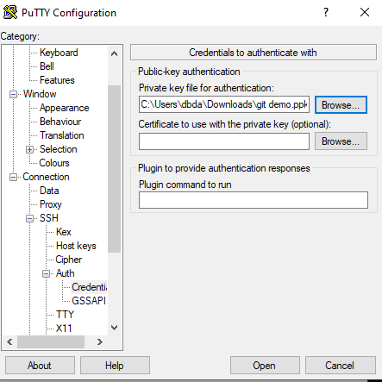

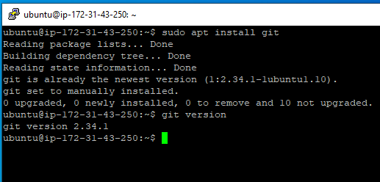

Q4. After installing git, pull your repository named ‘linux_scripts’. Run scripts inside this repository on ec2 instance. Take screenshots and save them in a docx file.





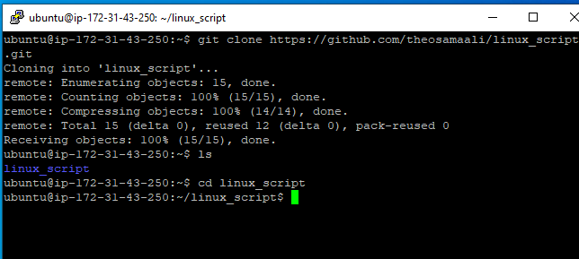

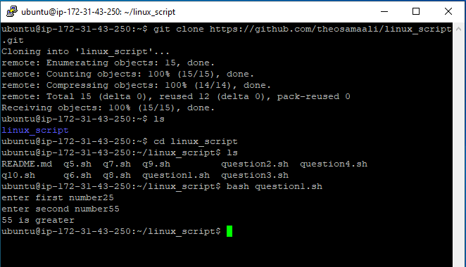

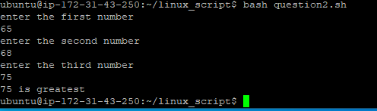

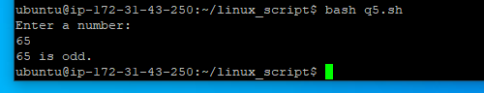

C:\Users\dbda\Desktop\cloud assignment 4\q 4.4.png

Q5. Create a new repository on Github named “linux shell scripting with AWS”. Put the docx file created in Q5 in this repository.

